ATM SYSTEM

C HAREESH

(192110282)

4) Draw a UML diagram for ATM System using CASE tool. The banking system allows a customer to access the financial transactions by ATM System, it has a step-by-step process describe the work of this process and elaborate the what are the work can do by customer, banking system, administrator and technicians with the ATM system.

**AIM:**

To develop a **UML Diagram** for an **ATM System** using a CASE tool, illustrating how customers, the banking system, administrators, and technicians interact with the ATM.

**PROCEDURE:**

1. **Identify Key Actors:**
   * **Customer**: Uses the ATM for financial transactions.
   * **Banking System**: Handles transactions and account validation.
   * **Administrator**: Manages ATM software and settings.
   * **Technician**: Maintains and repairs the ATM machine.
2. **Define the Work Each Actor Can Do:**
   * **Customer:**
     + Insert Card
     + Enter PIN
     + Check Balance
     + Withdraw Cash
     + Deposit Money
     + Transfer Funds
     + Print Receipt
     + Exit
   * **Banking System:**
     + Authenticate User
     + Process Transactions
     + Update Account Balance
     + Maintain Transaction Logs
   * **Administrator:**
     + Manage ATM Settings
     + Load Software Updates
     + Monitor Transactions
   * **Technician:**
     + Perform Maintenance
     + Repair ATM Issues
     + Refill Cash
     + Check Hardware Status
3. **Establish Relationships:**
   * The **Customer** interacts with the **ATM** to perform transactions.
   * The **ATM System** communicates with the **Banking System** for authentication and processing.
   * The **Administrator** configures and manages the **ATM System**.
   * The **Technician** ensures the ATM is functional and replenished.

**OUTPUT:**

**USECASE DIAGRAM:**

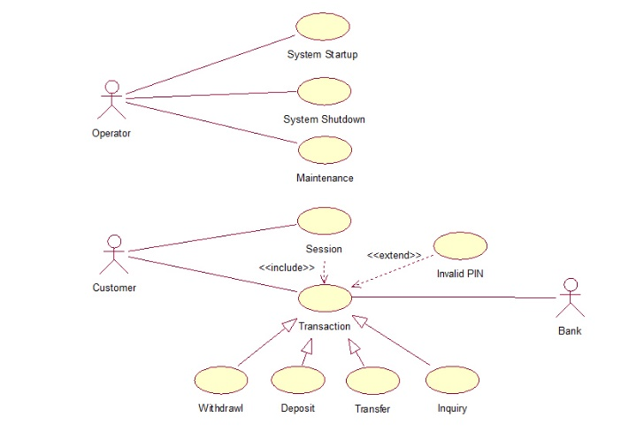

**SEQUENCE DIAGRAM:**

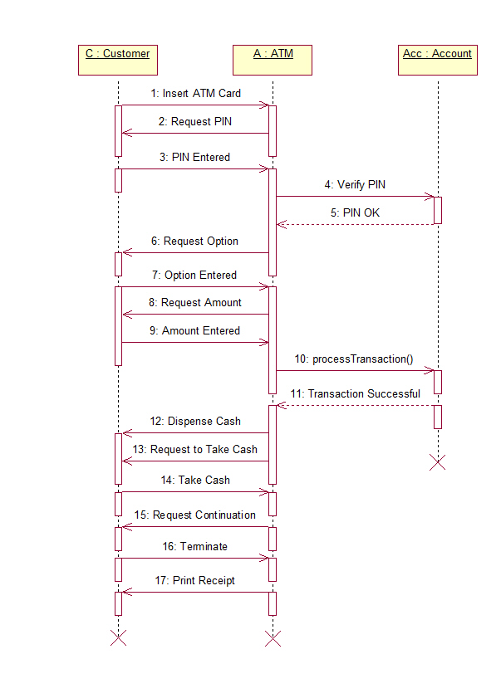

**COLLABORATION DIAGRAM:**

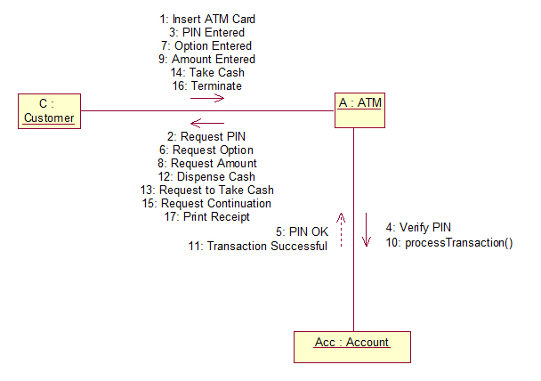

**STATE DIAGRAM:**

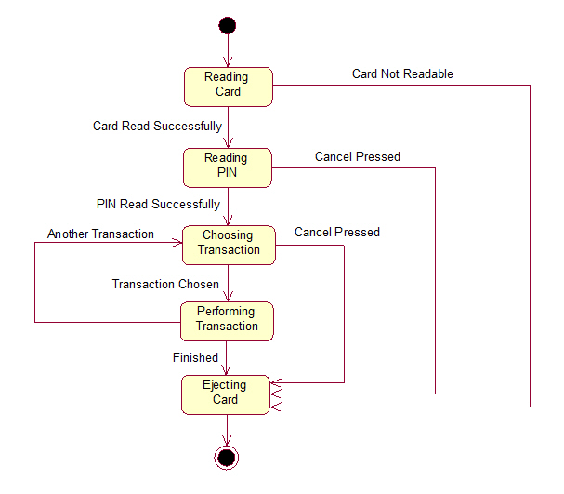

ACTIVITY DIAGRAM:

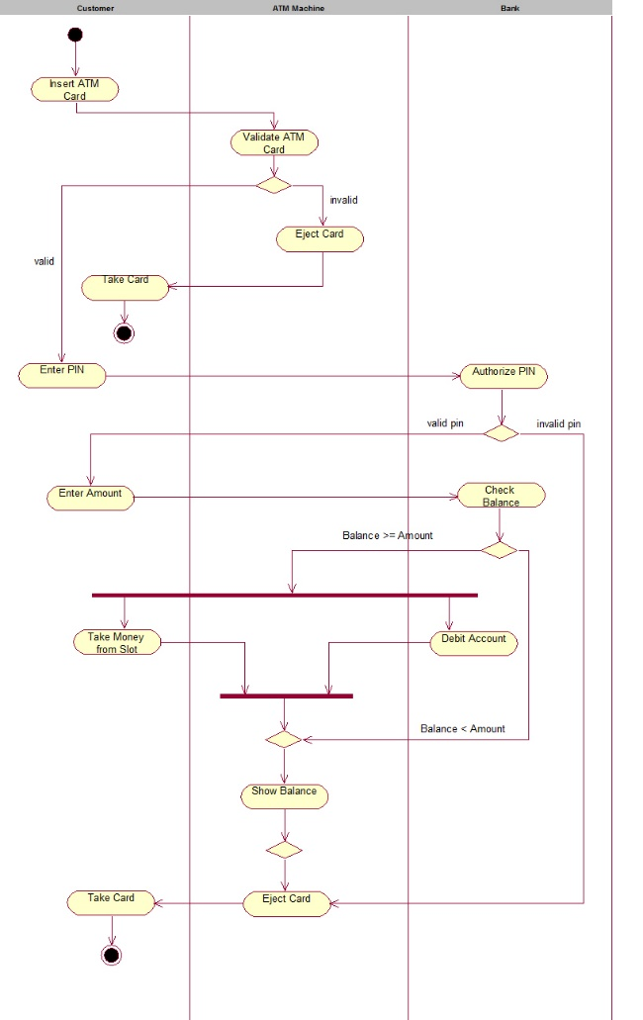

COMPONENT DIAGRAM:

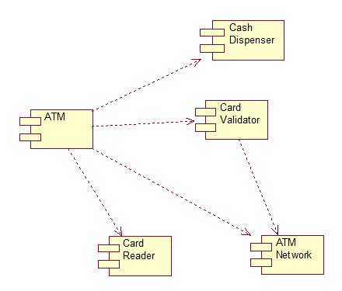

ACTIVITY DIAGRAM:

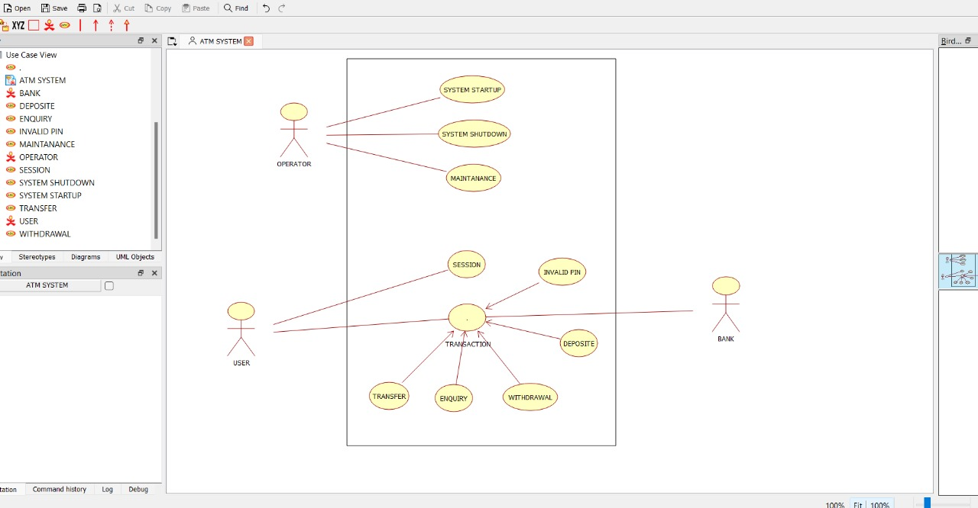

RESULT:

- UML DIAGRAMS IS SUCCESFFULY DESIGNED.